

**Department of Electronic and Telecommunication Engineering**

**University of Moratuwa**

**Analog Line Follower  
Report**

|  |  |
| --- | --- |
| **Name** | **Index Number** |
| Umadantha R.P. | 170648H |
| Farhath M.H.M. | 190169H |
| Fernando I.A.M.D. | 190172K |
| Fernando P.B.M. | 190178J |

**Abstract**

**The analog line following robot is an autonomous robot which can detect a white line (3cd width) on a black background and follow through it and stop at a white line perpendicular to the path. For this purpose, we cannot use any micro controllers or programmable ICs. therefore, we use operational amplifiers and transistors as main components and build the robot along with basic electronic devices. IR sensors are used for color detection and the error signal from IR sensor is calculated using Operational amplifiers. We use PID for controlling the motor signals. We designed the robot chassis by solid works and 3d printed it. Schematics for circuits done separately using Altium. We made two PCBs for the project and hardwired them with other parts and accomplished the task.**

**1.Introduction**

Robots are used for various fields nowadays. Most of the robots are autonomous and operated with micro controllers. Line Following Robots (LFR) are the most basic project for a robotic related study. LFR can be easily done by using micro controllers.

For our laboratory project we are requested to build an autonomous analog LFR. Analog LFR are made of only analog components like Operational Amplifiers, transistors, resistors, and sensors without using micro controller to operate.

* 1. **Task**

Building an analog line following robot which can follow a 3cm white line in a black background and the line consists of 900 turns, 900 curves and straight paths.

The robot specifications should be within 25cm * 25cm * 25cm (l * w * h).

The project was evaluated on the following criteria.

1. Design: Safety, Neatness, and suitability of electronic circuits.

2. Speed of the robot

3. Performance of the robot: Smooth Navigation, capability to stop at the end.

* 1. **Robot Specifications**

The Robot was 12cm * 15cm * 10cm (l * w * h). The robot consists of two 6cm diameter motor wheels and a castor wheel. The chassis has two stages. The IR sensor panel is mounted at the front of the robot. Robot consists of two PCBs, a power circuit, and a battery pack. One PCB is mounted on the bottom stage. The battery pack is mounted on the second stage. On top of that the second PCB is mounted with an elevation. The power circuit and motor driver are located at the back of the robot.

**2.Method**

**2.1 Bill of materials**

2.1.1 Sensor Panel Circuit

* 6 x TCRT5000 IR sensors
* 6 x 220 resistors
* 6 x 15k resistors
* Jumper wires

2.1.2 Comparator Circuit

* 2 x LM324N op amp
* 10k potentiometer

2.1.3 Adder Subtractor Circuit

* 1 x LM324N op amp
* 8 x 10k resistors
* 2 x 5k resistor
* 2 x 20k resistor
* 2 x 5.6k resistor

2.1.4 PID Circuit

* 1 x LM324N op amp
* 9 x 10k resistors
* 2 x 10k potentiometer
* 1 x 100k potentiometer
* 1 x 100pf capacitor

2.1.5 LED Circuit

* 6 x LEDs
* 6 x 220 resistors

2.1.6 Triangular Waveform Generator and PWM Generator

* 1 x LM324N op amp
* 2 x 100nf Capacitor
* 1x 100k resistor
* 2 x 40k resistor
* 1 x 15k resistor

2.1.7 Rectifier Circuit

* 6 x 10k resistor
* 2 x 10k potentiometer
* 2 x 1N4007 diode

2.1.8. Stopping Circuit

* 1 x SN74LS11N IC
* 1 x LM324N op amp
* 2 x 10k resistor

2.1.9 Power Circuit

* 4 x 3.7V 4800mAh Li-ion batteries
* 1 x 9V alkaline battery
* 1 x Buck converter
* 1 x LM7809
* 1 x LM7812
* 2 x 100nF capacitor
* 2 x 330nF capacitor

2.1.10 Motor Driver circuit

* L293N Motor driver Module
* 2 x 6V DC motors
* 2 x 100Ω potentiometers

Total Cost = Rs. 7000

**2.2 Main Circuit**

Connection between all the circuits of our design as shown in the flow chart. All the circuits of the above diagram from the sensor panel to the motor balancing variable resistors are described in methods. Even this implementation of our robot is looks like open loop system actuation of the motor act as the feedback to the system and therefore it behaves as a close loop system.

**2.3 Op amp IC**

LM324N op amp IC was used for the robot. LM324N consists of 4 op amps. It is a single power supply IC. Therefore, we were able to reduce the number of power lines. Also, LM324N is a low power and low-cost IC, therefore it was the most suitable choice for the line follower robot.

**2.4 Sensor Panel**

The sensor panel consists of 6 TCRT5000 IR sensors. TCRT5000 IR sensor has a 3mm phototransistor and 3mm IR emitting LED which are 5.5mm apart. The panel was built custom to suit the track parameters. The two center IR sensors are placed 3cm apart because the line is 3cm wide. The second pair of IR sensors are 2cm apart from the center IR sensors. The last pair of IR sensors is 1.5 cm apart from the 2nd set. The reason for this is to increase the reaction speed for large displacements from the line.

The sensor panel has a curvy nature.

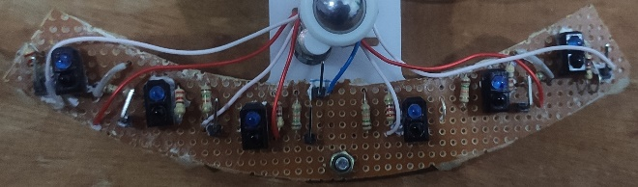

**2.5 Comparator Circuit**

Comparator circuit consists of 6 op amps. Signals coming from the sensors are compared with a threshold voltage by this circuit. The output will be 0V and 5V(digital). According to lighting conditions and height of the sensor panel from the floor and the arena floor conditions the threshold voltage need to be adjusted. A 10k trim pot is used to give a variable voltage to the comparators.

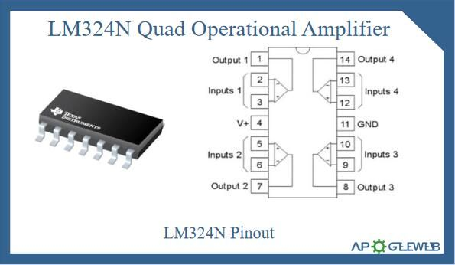**2.6 Adder Subtractor Circuit**

There are two Adder op amps. Signals from the right IR sensors and left IR sensors come into two separate op amps and they get added with different weights according to the relative position from the centerline. Signals from the closest sensor to the center line has less weight because when signals are coming from them the amount of corrective turning required is less. Therefore, higher resistor values are given to those signal paths. But as the sensor position is further away from the center line the amount of corrective turn required is higher. Therefore, higher weight is required when adding. Therefore, smaller resistors are used.

The signals from the right side and the left side of the sensor panel then get fed to the subtractor. The subtractor outputs the net corrective turn required. That is the error signal.

Error Signal = 1 * S1 + 0.5*S2 + 0.25*S3 +(-0.25) *S4 + (-0.5)*S5 + (-1)*S6

Where S1 to S6 are sensor digital readings.

**2.7 PID Circuit**

The error signals are fed into the PID circuit. But the error can have large variations and they will be overshoots. But when making turns, the robot should move smoothly. To take smooth turns PID circuit is used.

PID controller has three parts. Proportional, Derivative, and Integral control. The integrator is omitted from the circuit because the effect from the integrator is negligible. The PID circuit is implemented using 3 op amps (1 LM324N IC).

An inverting amplifier is used as the proportional controller and a differentiator is used as derivative output. Here we used 10nF capacitor for differentiator. Therefore, sudden changes within RC time constant can be removed from the error signal. To change the constants of proportional and derivative parts the outputs are fed to potentiometers. By adjusting the potentiometers, we can vary the effect of proportional and derivative parts.

The two outputs are then summed using an adder.

**2.8 Triangular Waveform Generator**

We used the Schmitt Trigger circuit to generate the square wave, which functions as an ON/OFF switch to the circuit.

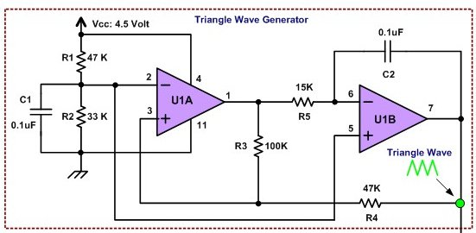The integrator generates the required triangle linear ramp (up and down) on its output using a 15k resistor and 0.1uF capacitor.

Schmitt trigger requires an initial voltage of either 5V or 0V. That is given through the grounded resistor path. The stability of the circuit is maintained through the capacitor.

**2.9 PWM Generator**

The PID output signals is compared with the triangular waveform using an op amp comparator to generate the PWM signals. When comparing to one op amp Triangular waveform is given to non-inverting terminal and PID signal is given to inverting terminal and to the other op amp the two signals are given the other way around. This is because the two motors need to be given opposite signals.

The comparators have a saturation voltage of +9V and -9V.

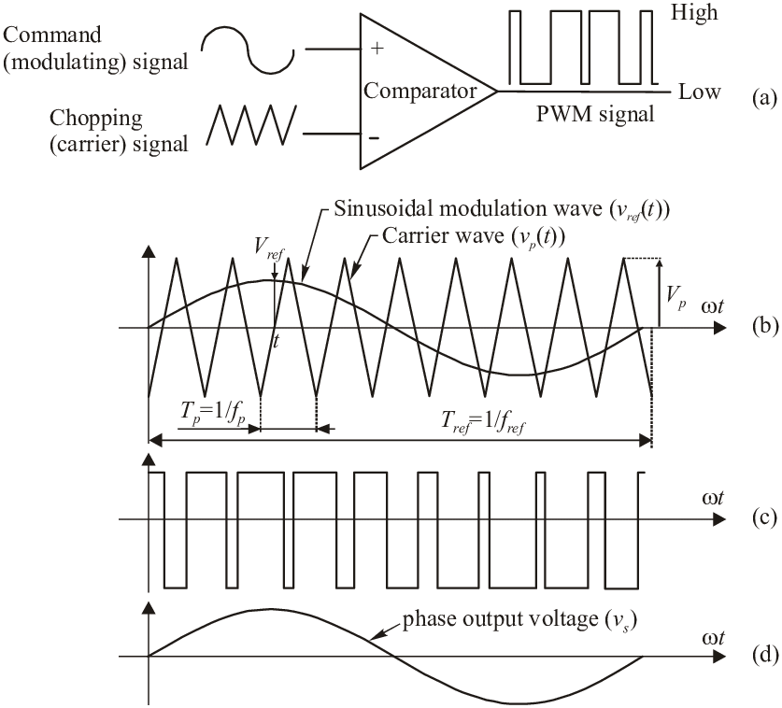

PID signal

Triangular Waveform

PID signal

**2.10 Rectifier Circuit**

The output of the PWM generator is between +9V and -9V. By this circuit initially the voltage is scaled down to +5V and -5V. Then using full wave precision rectifier circuit, the negative part of the signal is removed. The output of this circuit will be between +5V and 0V.

The op amp IC used for this was dissipating a lot of heat due to the rectification process. Therefore, heatsink was used.

**2.11 Stopping Circuit**

The stopping circuit uses the 6 comparator outputs. The 6 outputs are given as input to two 3 input AND gates and the outputs are given to another AND gate. The output of it is sent through a NOT gate which is made using an op amp.

If all comparator outputs are HIGH only then the output will be LOW. Only then the robot will stop. Then this signal is fed into the motor direction control ports of the motor controller.

Not Gate

**2.12 Power Circuit**

The main power supply is 15V which is provided by four 3.7V Li-ion batteries. Power circuit outputs 3 voltage levels. 5V,9V,12V. To output 5V a buck converter is used. Buck converter is chosen over LM7805. This is because when stepping down the main supply voltage of 15V to 5V a large amount of power is dissipated through the LM7805. +9V is supplied by regulating the supply using a LM7809 regulator. -9V is supplied through a 9V alkaline battery by grounding the positive terminal which then provides -9V from the negative terminal. 12V is supplied by regulating the supply using a LM7812 regulator.

As overall current drawn by the robot is around 2A, LM7809 and LM7812 regulators were getting heated quite a lot. Therefore, heatsinks were used.

**2.13 Motor Driver Circuit**

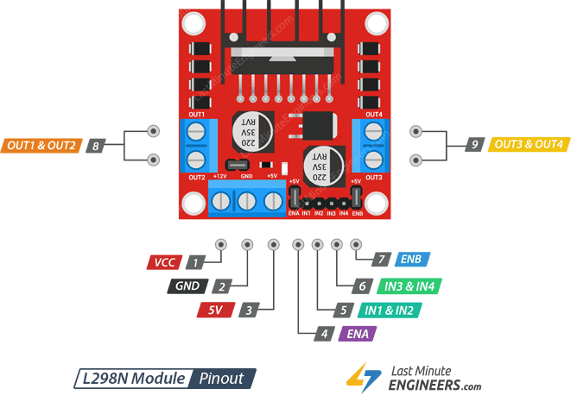L293d motor controller IC is utilized since the analog currents are insufficient to run the motors. With enable inputs, this is a dual motor H bridge motor controller. The enabling inputs are given left and right PWM signals, and the motors' inputs are given a 10 pattern to continually rotate the motors to the front. The speed of the two motors is controlled by PWM signals created in response to sensor inputs, allowing the robot to follow the line.

ENA, ENB pins are given the PWM signals and IN1, IN3 pins are given the stopping condition signals. VCC pin is given 12V. Motors are connected to 8,9 connectors through a 100Ω potentiometer. Potentiometer is used balance the speeds of the motors. The potentiometer was tuned to about 20Ω after testing. Ideally the potentiometer used here should be a high-power potentiometer, because if the stall current flows through the potentiometer there will be large power dissipation through the potentiometer.

**2.14 Circuit Design**

The whole Circuit was divided into 3 main PCBs. Namely, power circuit, PWM generator PCB, Main PCB (Comparator, adder, PID, Stopping circuits). The Schematics and PCBs were designed using Altium software. All Schematics and PCBs are included in the appendix.

**2.15 Chassis Design**

The chassis was manually designed using Solidworks and was physically implemented using laser cutting. The chassis has dimensions 12cm x 15cm and 2mm thickness and has 6cm diameter wheels.

Solidworks design and physical implementation is included in the appendix.

**3.Results**

**3.1 Sensor Panel and Readings**



Readings obtained by the sensor panel for black surfaces were in the range 0V-1V under different lighting conditions and surface conditions. For white color readings were in the range 4.3V to 5V. The threshold voltage was about 3.5V.

**3.2 PID Outputs**

For the proportional part of the error is observed as 0.9V, 2.3V,7.1V for the first second and third sensors from centerline to the edge of the sensor panel.

When sudden changes occurred the error signal gave no distortions and there were no overshoots due to the differentiator part.

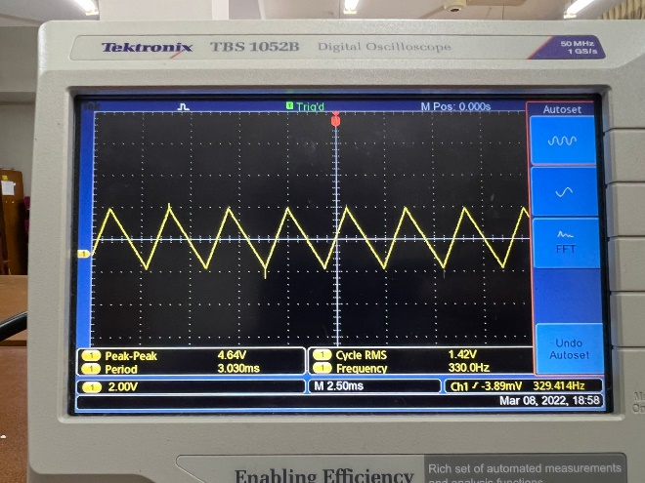**3.3 Triangular waveform**

Triangular Waveform

Triangular waveform was generated with a frequency of 330Hz, and the peak-peak voltage was adjusted to 18V.

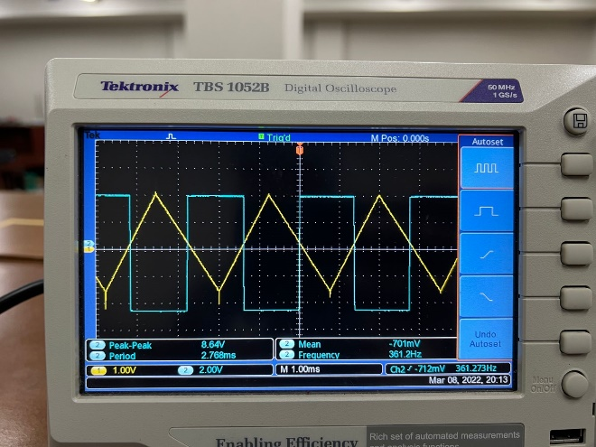**3.4 Comparing Error Signal with Triangular waveform**

Error Signal and Triangular Wave Comparison

This shows the comparison of the Triangular waveform with error signal.

**3.5 Left motor and right motor PWM signals**

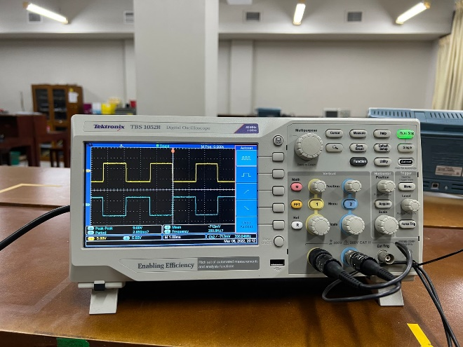Left motor and right motor have mirror imaged PWM signals. For a example when one motor is running on 25% duty cycle the other will be running on 75% duty cycle.

PWM Signal

**3.6 Main PCB**

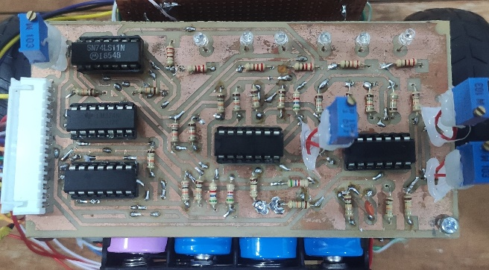Main PCB consists of Comparator circuit, LED array, Adder Subtractor circuit, PID control circuit, Stopping circuit.

PCBs were manufactured locally, and the quality of manufacturing was low. Some of the tracks were scraped off with time and some tracks were easily removed while soldering. Therefore, to avoid removing of tracks, after soldering and checking the circuit fully, we applied an insulative glue to ensure no tracks were removed and no tracks get scraped off.

After manufacturing and checking the circuit, we found out that the footprint for the potentiometers were wrong in the Altium software. Therefore, we had to swap the leads of the potentiometers by elevating them from the PCB level. Since wires were connecting potentiometers to the PCB, we used glue to reduce stresses caused on the soldering of them.

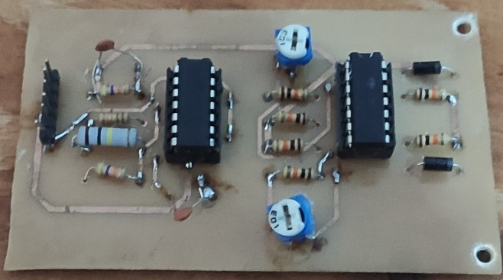**3.7 PWM Signal Generator PCB**

This PCB contains the triangular waveform generator circuit and rectifier circuit.

**3.8 Chassis**

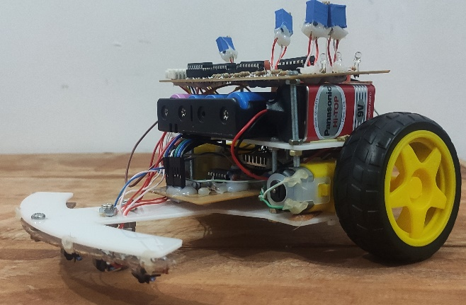

The chassis was laser cut using 2mm thick white opaque acrylic.

**3.9 Performance in arena**

Robot was able to take 90 degrees turns to both sides and it could follow curve paths and straight paths without any oscillation.

Overall run was smooth, and the robot was able to complete the task successfully.

**4.Discussion**

**4.1 Component selection**

To sense white line and stopping line we used TCRT 5000 senser which contains both IR led and Photodiode in one package with proper isolation. Then we used Op amps as comparators, adder, subtractors, scalers and rectifiers. As our triangle wave generator oscillate at 330Hz speed reaction speed of the robot will be around 3ms 0.3V/us of slew rate will be sufficient for all the op amp activities in our circuits.

To keep the cost of the project lower we used 6V brushed DC gear motors which having 0.8A stall current and 0.8kg/cm stall torque. This motor is capable to give requires acceleration and momentum to achieve the reaction speeds required for the robot. To drive the motors and power the control circuit we used four 3.7V 18560 Li-ion batteries with 4800mAh capacity. In practice battery pack facilitate 1600mAh capacity and the total sum of current drawn from batteries is around 2.0A. therefore we could power the robot for 30 minutes with these settings.

In the power circuit, we used 7812 and 7809 voltage regulators to give 12V to the motor driver circuit and to supply 9V to the controller circuit. And we used buck convertor to give 5V to the sensor panel circuit. The reason we cannot use normal regulator for this is the conversion between 15V to 5V will dissipate huge amount of power even for small amount of current but buck convertor can avoid this as it uses switch mode regulation.

**4.2 Design specifications**

In our physical implementation we design our sensor panel with curve shape, so the error signal generated from IR sensors will be more linearly proportional to the angular displacement of the robot to the white line so the differential drive of the motors can act as proper feedback to the robot as we manage to maintain the center of mass in the middle of the robot.

We design all our circuits in two PCBs. Debugging the circuit will be easier when the modules of circuits are having separate PCBs, but the cost and effort must spend on designing and assembling many PCBs is higher therefore having two PCBs is beneficial in both ways.

In this project we came across many situations where we had to think about balance between cost, speed, accuracy of the system from the design phase to up until end of the project. Selecting motor balancing mechanism in the design, selecting frequency for triangular signal, selecting the motors are some of them.

**4.3 Suggested improvements to the system**

After solving all the issues in this robot, we can design one PCB for the complete design including power circuit without having two PCBs so the amount of wires and connectors will be less and design will be much more elegant.

And variable resistors we used at the last stage can burn out in stall current if the resistor values is set to less than 10 ohms. As we demonstrate the system using resistor value like 20 ohms there will not be any issues. But as a improvement can use high power variable resistor or nichrome wire to overcome the problem.

**5. Acknowledgements**

Completion of this project was not an easy task with the situation the country. Finding components was a very difficult task.

We would like to pay our gratitude to Mr. Lahiru Wijerathna our project supervisor for the continuous guidance he gave showing the right ways to implement circuits and also helping us find components. We would also like to thank Mr. Bhanuka Silva for the very important comments he gave about our PCB design which helped us improve our PCB design.

**6.Bibliography**

<http://www.will-moore.com/analog-line-follower>

<https://www.alldatasheet.com/view.jsp?Searchword=Lm324n&gclid=Cj0KCQjwsdiTBhD5ARIsAIpW8CJyLrHcl-MMSSmf3A0dDIb_tZQ7N1URY16WOq5C7xbsYx0G-mTirpAaAuxkEALw_wcB>

<https://www.ti.com/lit/ds/symlink/l293.pdf>

<https://edu.ieee.org/lk-uomras/blog/analog-line-following-robot/>

<https://learnabout-electronics.org/PSU/psu31.php>

<https://circuitdigest.com/electronic-circuits/half-wave-and-full-wave-precision-rectifier-circuit-using-op-amp>

**7.Apendix**

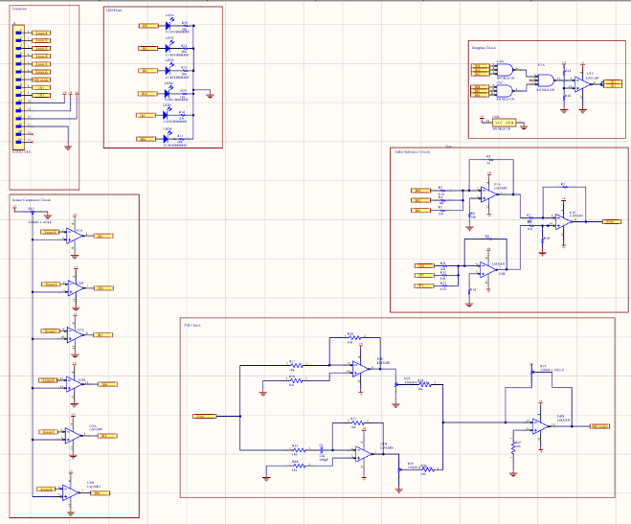**7.1 Schematic Diagrams**

Main Circuit Schematic

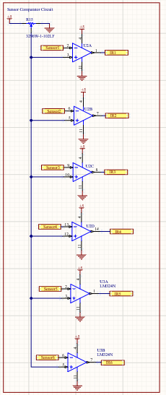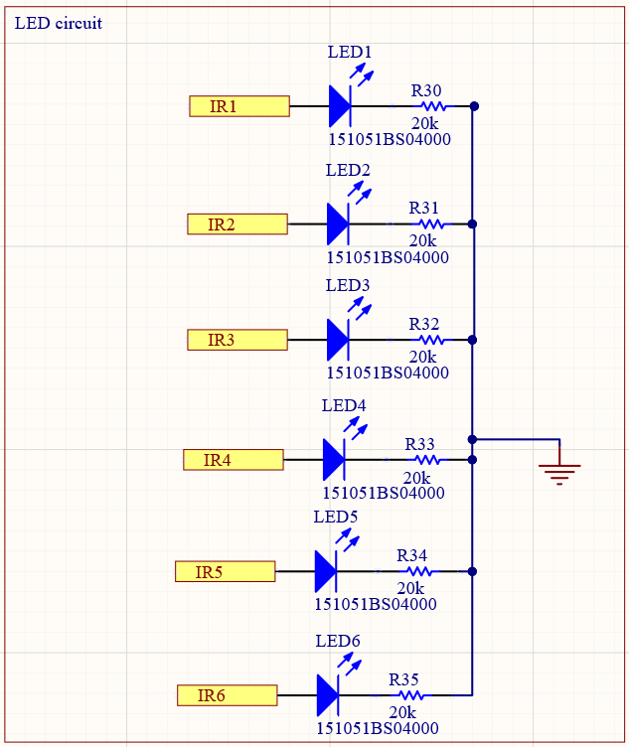

Comparator Circuit

LED Circuit

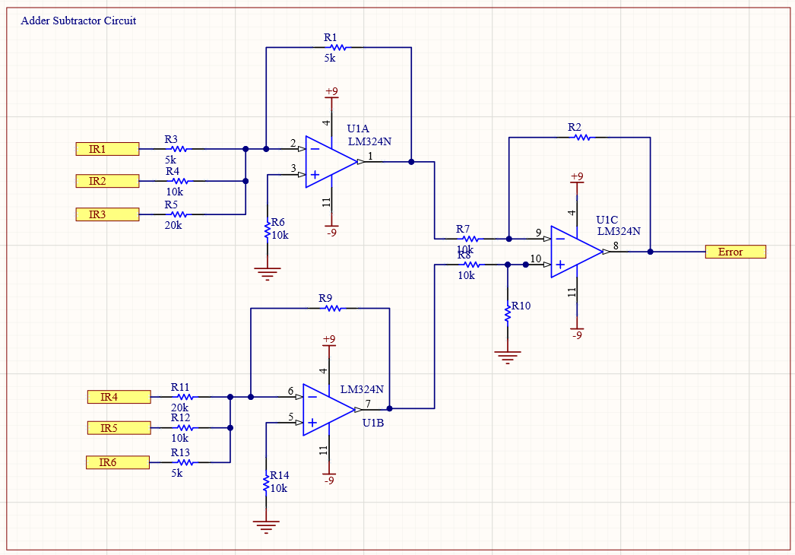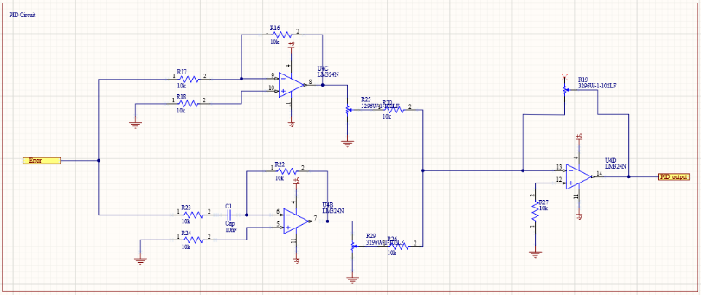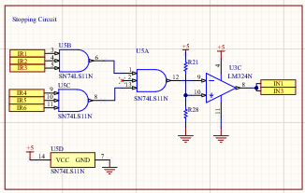

Adder Subtractor Circuit

PID Circuit

Circuits of PWM Generator

Stopping Circuit

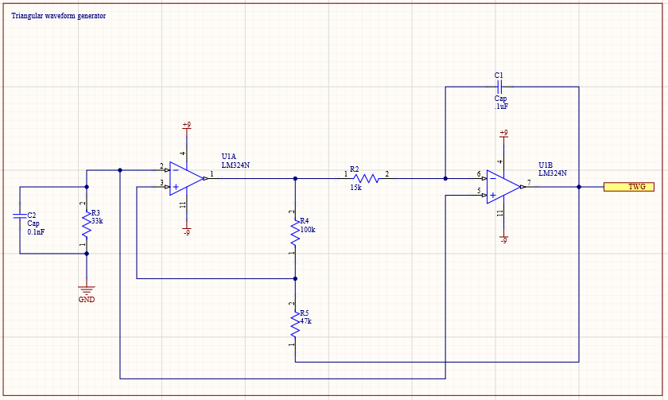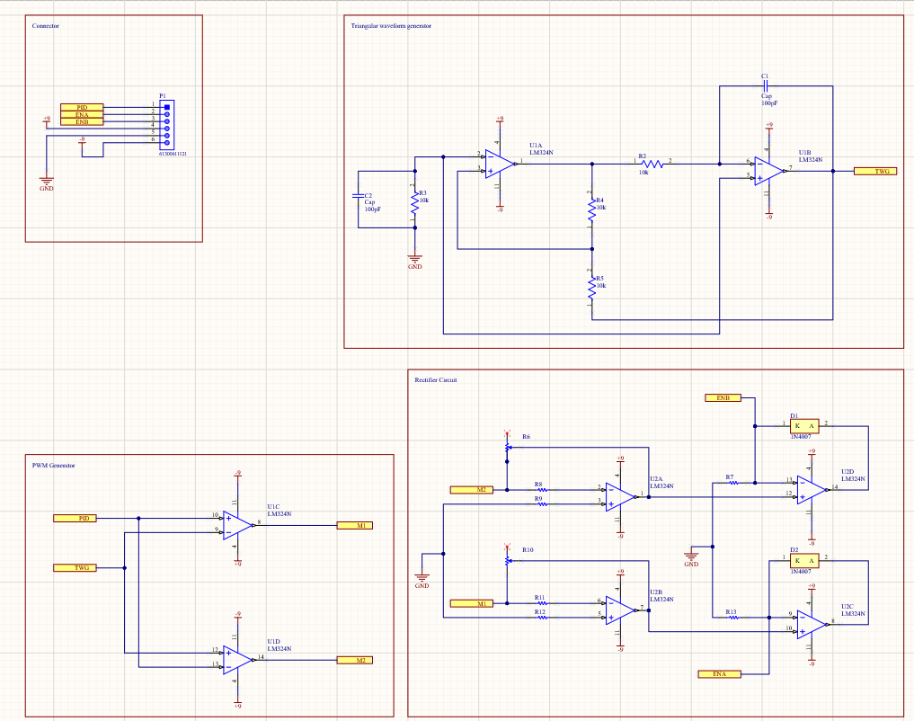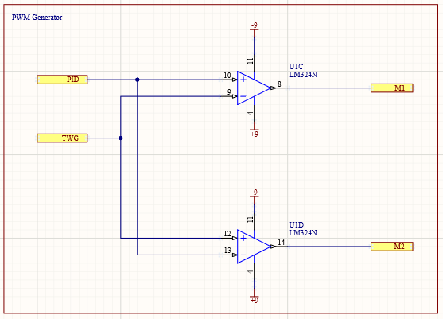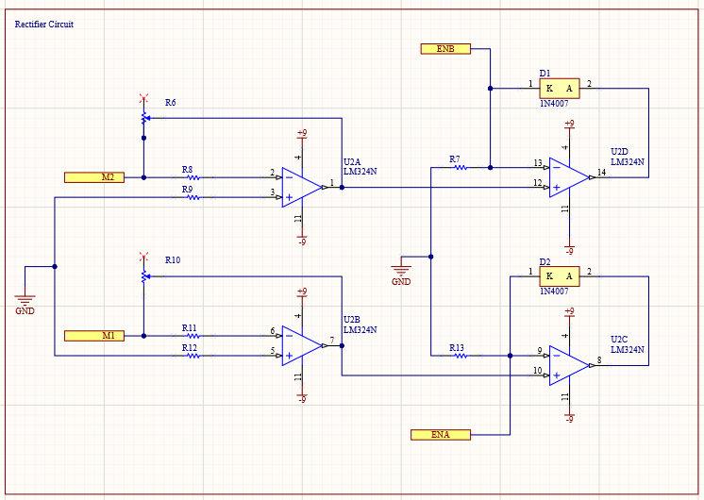

PWM Generator Schematic

**7.2 PCB**

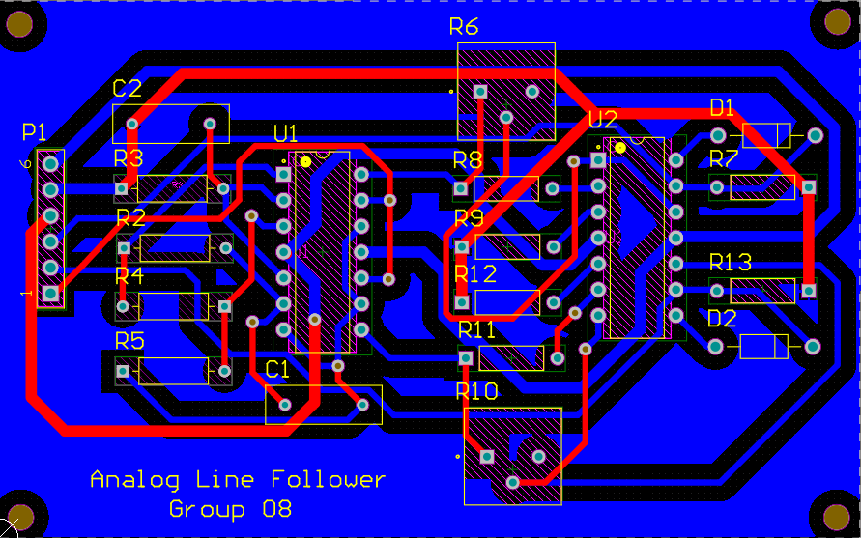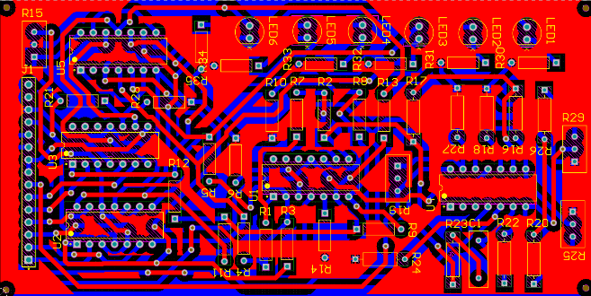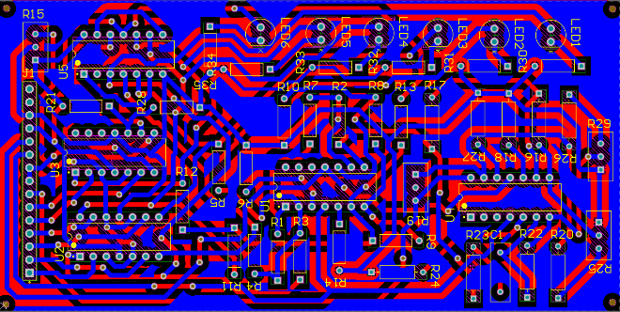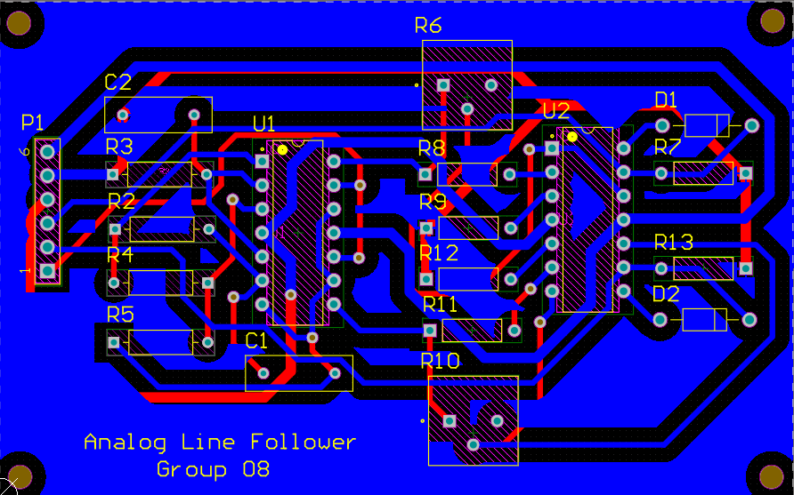

3D Design

Main PCB Bottom Layer

Main PCB Top Layer

PWM Generator PCB Top Layer

PWM Generator PCB Bottom Layer

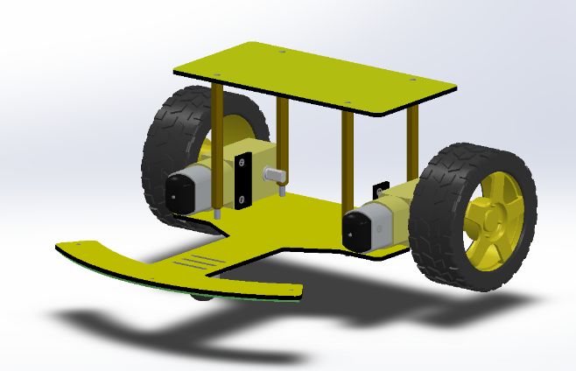**7.3 Solidworks Design**

**7.4 Robot**

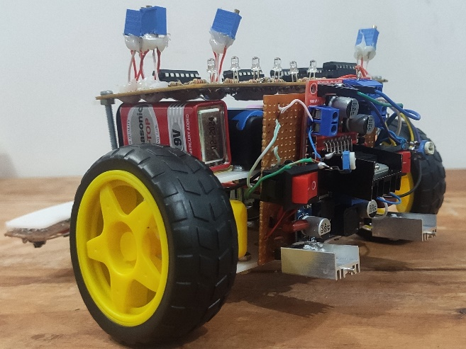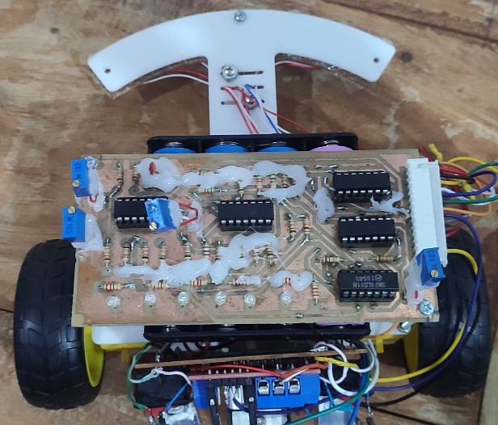

Physically Built Robot

**8. Contributions**

|  |  |
| --- | --- |
| Umadantha R.P. | Adder Subtractor Circuit design, Schematic Drawing, Soldering |
| Farhath M.H.M. | Sensor panel and comparator, Stopping circuit design, Schematic Drawing, Soldering |
| Fernando I.A.M.D. | Triangular waveform circuit and PWM generator circuit design, Schematic drawing, PCB design, Solidworks design |
| Fernando P.B.M. | Power circuit, Rectifier Circuit, Motor control circuit design, Soldering, PCB design, Solidworks Design |